# Flight Delays and Cancellations

## Insight 1 – What causes the delays?

[Link to the public Dashboard](https://public.tableau.com/views/FlightCancellations_15889582888310/Cancelations?:display_count=y&publish=yes&:origin=viz_share_link)

This dashboard consists of four worksheets that look at the flight delays from different perspectives:

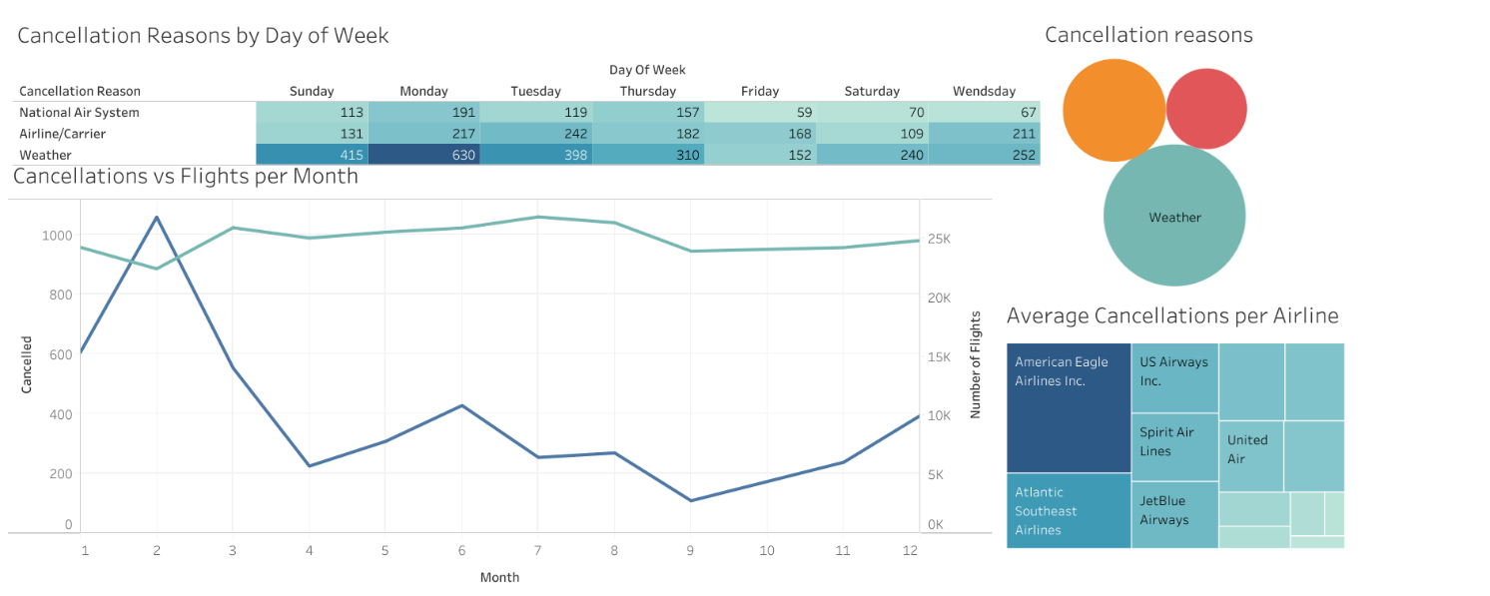

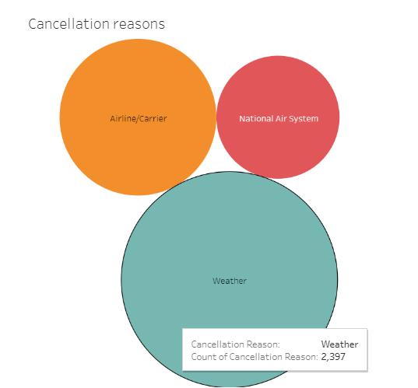This dashboard gives us an overview of what are the factors surrounding the delays: day of the week, month of the year, airline. It also sees into the most common cancellation reasons.

* Weather is the most common reason why flights get cancelled, causing more than half of the cancellations. 2397 flights were cancelled because of the weather during the year 2015.
* Monday is the day of the week that more cancellation gets, having 630 cancelled flights due to weather reasons only. On the other hand, Friday is the day with the least amount of cancellations, having only 379 in total compared to the 1038 cancellations on Monday.

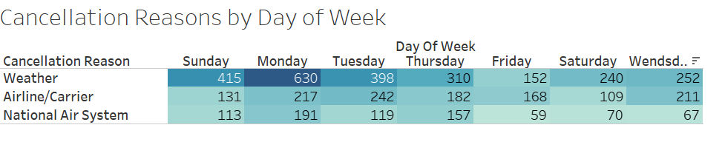

In the month of June, Spirit Airlines has the most average delay (Average Arrival Delay: 36.83 , Average Departure Delay: 37.39) of a total of 497 flights.

In the month June, American Eagle Airlines, has the most percentage of flights diverted (0.76% or 10 diverted flights)

In the month of June, Spirit Airlines, has the most percentage of flights cancelled (4.63% or 23 cancelled flights)

## Insight 2

## Insight 3